#### 21st Quarterly Meet, IEEE Delhi Section

The 21st edition of the Quarterly Meet of IEEE Delhi Section was hosted by the IEEE Student Branch of Punjab Engineering College, Chandigarh, as a one-day event on 01st September 2013. The primary agenda of the meet was the congregation of student members and office bearers of student branches under one roof so as to facilitate networking and discuss the various problems that impede the smooth functioning of student branches in the section. A delegation of 16 members, including 15 students from the executive committee of BVPIEEE attended the meet along with one active volunteer and IEEE student member, Kshithij Kaushik.

The welcome address delivered by the Vice-Chairperson of IEEE PEC was followed by a lamp lightning ceremony and a motivating speech by the respected branch counselor, Dr. Rintu Khanna. The main event kick started with an icebreaking activity wherein all attendees were grouped randomly to create a persuasive commercial for chimerical products, excellently serving the purpose of networking. The delegation from BVPIEEE actively participated in the group activity and efficiently utilized the much awaited problem discussion session, hosted by Mr. Rahul Batra, Vice-Chairperson, IEEE Delhi GOLD. This session provided the office bearers of our student branch with a supple platform to take valuable advice from the invited dignitary, regarding issues pertaining to the branch.

The ‘Industry Seeks’ expert talk from IATC-Siemens arranged by the host student branch gave another reason to a few electronics enthusiasts from our delegation to attend the meet. Live demos on Automation, SCADA, PLC and presence of industry leaders giving an insight into the latest technology added to the bright learning environment.  
  
The event concluded with a vote of thanks by the Secretary, PEC Student Branch.

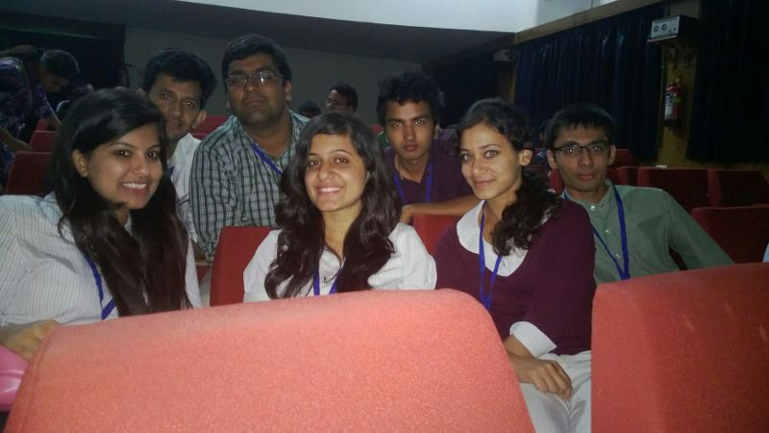  
Udit Khanna,  
Student representative, BVPIEEE.